**Stratigraphic section of the seismic data collected in the north Beaufort Sea**

**Introduction**

What is the permafrost?

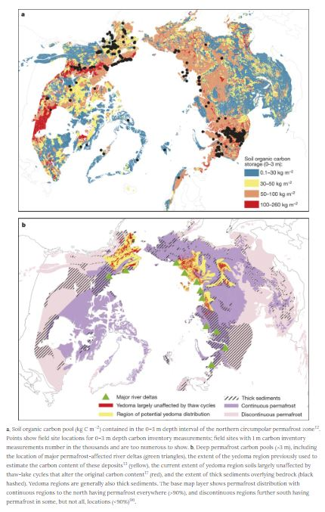 The permafrost is a type of soil in the northern regions that stay under 0°C for at least 2 years. Considering this fact, different type of soil can be turn into permafrost as organic soil that contain microbiological structure. Over time, the decomposition of those microbiological structures creates gas inside the permafrost, such as methane (CH4) and carbon dioxide (CO2). For the last 50 years, studies have shown that there is a thaw process in the northern region with that soil. This thaw is directly related to climate change, because there is a gas release which influence the climate. Thus, a warming climate can induce an acceleration of the microbiological breakdown and release all the greenhouse inside the permafrost (Schuur et al., 2015). However, it remains some questions about the real effect of the release of those greenhouses.

Figure 1: Localisation of the permafrost in the northern region.

New research published since the Intergovernmental Panel on Climate Change (IPCC) showed the size of the carbon pool that are stored in the northern region (Schuur et al., 2015). The synthesis of those studies confirmed that tremendous quantities of deep carbon have been widespread. Furthermore, models have difficult to evaluate the quantity of trap carbon and scientist may underestimate the quantity of the carbon pool (Schuur et al., 2015).

Most of the researches have been on the terrestrial area where the cold temperature are located. However, permafrost can be under water where the permafrost exist as an extension of the continental shelf. Subsea permafrost is known to be the permafrost that has been submerge during the last Ice Age (Pleistocene-Holocene) (Shuur et al., 2015). Over years, the subsea permafrost has been eroded with the water, so the amount of the carbon pool tend to be less important. However, the permafrost under the ocean is less quantify than the terrestrial one. Furthermore, there are layers of permafrost under the sea that trap the carbon pool in some localisations. However, it does not prevent the 17 Tg of CH4 (1Pg = 1000Tg) that are release each years according to the last investigation (Schuur et al., 2015).

https://www.nature.com/articles/nature14338

Geology of the Beaufort Sea

The Beaufort Sea is well known for the abundance of permafrost that are located as much onshore as offshore. As summarized in Grantz et al. (2011), the development of the Canada basin started with a rifting phase during the Cretaceous witch was follow by a phase of flooding by the south into the Mackenzie basin. During the beginning of the Eocene, tectonism in the region caused unconformity and sequence-bounded from the Mackenzie River. After that, West-East compression caused folding and thrusting in the Beaufort bed in the Mackenzie Valley region. A late Miocene unconformity is overlain by a thick, prograding sequence of Plio-Pleistocene muds including deltaic bodies, shelf-edge facies and abundant mass failure. The stratigraphic units defined by Dixon et al. (1994) and Graves et al. (2010) include the Kugmallit Formation associated with the most recent pull-apart, the thick Mackenzie Bay (over the Miocene unconformity), followed by the equally thick Akpak Formation, and a Pliocene shelf-top wedge with thick and multiple-failed slope equivalents termed the Iperk Formation (Kang et al. 2017). However, those last formation has been partially eroded by the glacier has a deep evaluated at 300 meters. That erosion is located in the Mackenzie Trough which was filled afterward (Batchelor et al. 2013). During the glacier period of the Neogene and the Quaternary, the Mackenzie trough was filled with fine-grained of fluvio-deltaic sediments. Later in the Quaternary, periods of Tills last deposed on the Beaufort Sea shelf at different times. This unique geological artic formation was found some years ago and showed the connected permafrost in that region (Batchelor et al., 2013). Due to a lack of information and different challenges, this region was not study in the past until now. These studies have been done recently with the Geological Survey of Canada (Jin et al. 2017) to understand the offshore permafrost distribution in the Beaufort Sea especially in the Mackenzie Trough.

The Mackenzie Trough

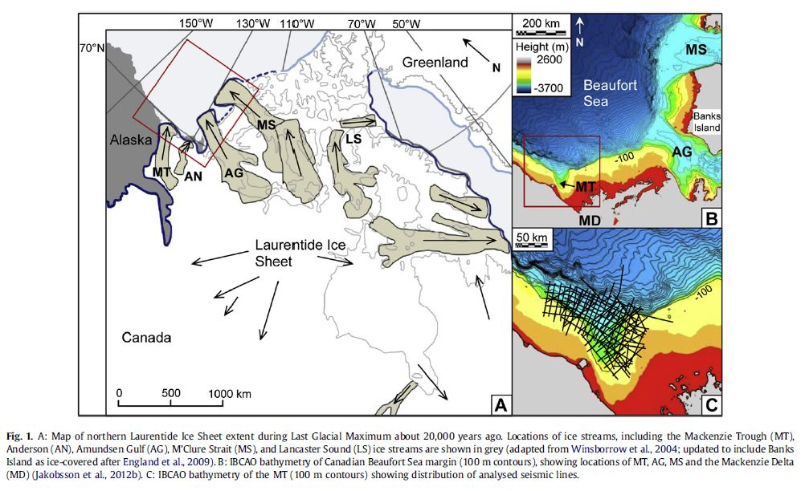The Mackenzie Trough is a major bathymetric depression who is located in the Mackenzie Bay in the Beaufort Sea. His localization represents ice streams which drained the north-west margin of the Laurentide Ice sheet (Fig1.a) during the Quaternary glaciation. The Mackenzie Trough on the western Canadian Beaufort Sea margin is a 150 km-long, partially-infilled linear depression, which extends in a NNW direction from the modern Mackenzie River Delta to the continental shelf break at around 800 m below present sea level (Fig. 1B and C) (Batchelor et al., 2013).

Figure 2: Localisation and bathymetry of the Mackenzie Trough

As it’s said before, the shelf of the Beaufort Sea is mainly fills with glacial deposit who were deposed 12 to 30 thousand years ago. Those types of sediments are known to be very chaotic when there are characterises with seismic reflection. As it’s showed in Bachelor et al., 2013, those chaotic structures can be represented as melting water and a large variation of the topography into the till. Furthermore, there is around five types of tills into the shelf of the Beaufort Sea and every single tills has different structures and different reaction with the seismic reflection (Batchelor et al., 2013). These tills will be show on the stratigraphy section that will be in this study. However, those stratigraphy are unique for the region of the Mackenzie Trough.

Feature of the permafrost

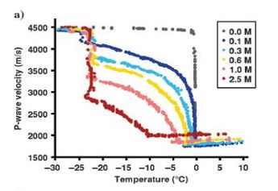As now the geology of the Mackenzie Trough has been quickly summarized, it is important to have a look at the geology in the Beaufort Sea. This report will analyse the data of Jin et al., 2017 to do a stratigraphy section of the shelf of the Beaufort Sea. In the previous report of the Geological Survey of Canada, the experts did multiple works with geophysics, geothermal and taking sample directly on the sea to analyse the shelf. It is important to consider the influence of the temperature, the salinity in the permafrost, the saturation, the percentage of ice into the permafrost and the core of the grains in the shelf. All these factors have an influence about how the P-wave will reflect on the shelf (Dou et al., 2016). Thus, Dou et al., 2016 showed that when the salinity of the permafrost shelf is higher, the capacity of the soil to maintain the ice pore is weaker. That characteristic influence the P-wave that pass through the permafrost when there is thaw in the soil. In this same report, Dou et al., 2016 showed the influence of the temperature in the soil with different salinity versus the velocity of the P-waves. Thus, the P-waves velocities dropped faster with thaw when the salinity is higher. Otherwise, when the permafrost contain less salinity, the P-wave tends to be higher during the thaw. Log data have been collected from 200 m to 2000 m in the shelf of the Beaufort Sea and it showed that the marine sediment are fresh, so without salinity (Frederick et al., 2015). Those data will help to interpret the stratigraphy section of the shelf of the Beaufort Sea.

Figure 3: P-waves velocity function of the temperature

In the area of the Beaufort Sea, the thickness of the permafrost has a range from 130 m to 650 m [Collett et al., 1989; Osterkamp and Payne, 1981]. The P-wave of those coarse-grained sediments change with the percentage of ice in the soil. Thus, ice-bonded sediment has a velocity range from 2300 ms-1 to 5000ms-1 and unfrozen sediment from 1700 to 1900 ms-1 (Brothers et al., 2016). In this same report, Brothers et al., 2016 showed that the higher velocity are onshore where there is an abundance of permafrost while the offshore permafrost has lower velocity. However, there is no straight line that define the lack of permafrost offshore. There is some continuity of offshore permafrost located NE of the Mackenzie Delta (Brothers et al., 2016). Thus, the shelf of the Beaufort Sea is not only made with permafrost, there is also others geological formation as it showed higher in this report.

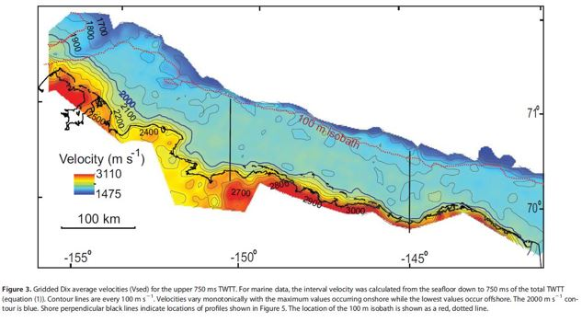

Figure 4: Velocities measures in the Beaufort Sea onshore and offshore